CAT VS DOG IMAGE CLASSIFICATION
End-to-End Business & Technical Documentation

DOCUMENT CREDENTIALS
• Project Name: Cat vs Dog Image Classification
• Industry: Artificial Intelligence / Computer Vision
• Prepared By: Shaili Jaiswal, Data Science Intern
• Experience Level: Early Career / Intern
• Team Size: 3
• Role: Data Preprocessing, Model Development, Evaluation, Documentation & Deployment
• Version: 1.0
• Confidentiality: Internal / Educational Project

INDEX (TABLE OF CONTENTS)
1. Abstract
2. Executive Summary
3. Business Understanding
4. Problem Statement
5. Data Source and Description
6. Data Quality Assessment
7. Exploratory Data Analysis (EDA)
8. Feature Engineering & Image Preprocessing
9. Data Splitting Strategy
10. Model Development
11. Transfer Learning with VGG16
12. Model Evaluation & Comparison
13. Final Model Selection & Justification
14. Model Interpretability
15. Business Insights
16. Code Structure & Implementation Details
17. Deployment Alignment
18. Risks & Limitations
19. Assumptions
20. Retraining Strategy
21. Ethics & Bias Considerations
22. Final Deliverables
23. Conclusion
24. Technical Glossary

1. Abstract
This project delivers an end-to-end deep learning solution for image classification in the Computer Vision domain. Historical image data of cats and dogs was analyzed to understand image patterns, visual features, and classification behavior. A structured deep learning lifecycle was followed, including data quality validation, exploratory analysis, image preprocessing, feature extraction, model development, transfer learning, and rigorous evaluation.
The dataset consisted of labeled Cat and Dog RGB images organized into separate training and validation categories for supervised binary image classification. Multiple deep learning architectures including Artificial Neural Networks (ANN), Convolutional Neural Networks (CNN), Transfer Learning using VGG16, and ResNet50 were implemented, benchmarked, and compared using business-aligned evaluation metrics.
The final VGG16 transfer learning model achieved approximately 96% validation accuracy and demonstrated strong generalization capability on unseen image samples. The solution supports probability-based predictions, real-time inference, and scalable AI deployment workflows.
The final trained model can be deployed using Streamlit, Flask, FastAPI, and mobile deployment frameworks, making the solution suitable for real-world Computer Vision applications and intelligent image recognition systems.

2. Executive Summary
Image classification is one of the most important applications of Artificial Intelligence and Deep Learning. In modern AI-driven systems, automated image recognition helps businesses improve efficiency, reduce manual effort, and enhance user experience across various domains such as healthcare, surveillance, social media, e-commerce, and smart automation systems.
This project focuses on understanding and classifying cat and dog images using historical image datasets and advanced Deep Learning techniques. The objective is not only to accurately identify whether an image belongs to a cat or a dog, but also to understand how different deep learning architectures perform in image recognition tasks.
The solution leverages Deep Learning and Computer Vision techniques to analyze image patterns, textures, shapes, and visual features. Multiple models including Artificial Neural Networks (ANN), Convolutional Neural Networks (CNN), Transfer Learning using VGG16, and ResNet50 were developed, evaluated, and optimized to ensure robustness, reliability, scalability, and real-world deployment readiness.
The final output of this project is an intelligent image classification system that provides:
• Accurate cat and dog image classification
• Probability-based prediction capability
• Real-time image prediction support
• Deployment-ready .keras deep learning model
• Scalable Computer Vision pipeline for future AI applications
This documentation explains what was built, why it was built, how the deep learning pipeline works, how different models were evaluated, and how the final solution can be maintained and deployed for long-term usability and scalability.

3. Business Understanding
3.1 What Is Image Classification
Image classification refers to the process of automatically identifying and categorizing objects present in an image using Artificial Intelligence and Deep Learning techniques. In Computer Vision, image classification enables machines to analyze visual patterns and assign images to predefined categories.
In this project, the deep learning system is trained to classify images into two categories:
• Cat images → Class 0
• Dog images → Class 1
The model learns important visual features such as facial structure, fur texture, body shape, ear patterns, and image characteristics to accurately distinguish between cats and dogs.
3.2 Why Image Classification Matters
Image classification is one of the most widely used applications of Artificial Intelligence and Computer Vision across multiple industries. Automated image recognition helps organizations reduce manual effort, improve efficiency, and enable intelligent decision-making systems.
Image classification is widely used in:
• Healthcare imaging and disease detection
• Smart surveillance and security systems
• Social media image tagging and automation
• Pet recognition and animal monitoring applications
• Autonomous vehicles and robotics
• Retail product recognition systems
• E-commerce recommendation systems
• Industrial quality inspection systems
Accurate image classification systems improve scalability, automation, and operational efficiency in real-world AI applications.
3.3 Business Goals of This Project
The key business and technical goals addressed by this project are:
• Build an accurate deep learning image classification model
• Automate cat and dog image recognition
• Reduce manual image classification effort
• Develop an efficient Computer Vision workflow
• Evaluate multiple deep learning architectures
• Implement transfer learning using pretrained models
• Enable real-time image prediction capability
• Create a reusable AI inference pipeline
• Demonstrate an end-to-end Computer Vision implementation
• Support scalable image recognition applications
The project also focuses on comparing different deep learning approaches including ANN, CNN, VGG16, and ResNet50 to identify the most effective architecture for real-world image classification tasks.
Potential real-world applications include:
• Veterinary AI systems for automated animal identification
• Pet adoption and pet management platforms
• Smart surveillance and monitoring systems
• Educational AI-based image recognition applications
• Automated pet classification and tagging systems

4. Problem Statement
Despite having large volumes of image data, manually identifying and classifying images accurately is extremely difficult and time-consuming. Image classification tasks become more challenging due to variations in image quality, lighting conditions, object position, background noise, image orientation, and visual similarities between different classes.
In Computer Vision applications, extracting meaningful visual patterns and distinguishing objects through traditional programming approaches is highly complex. Accurate image recognition requires advanced Deep Learning models capable of learning spatial patterns, textures, edges, and object-specific features automatically from image data.
The problem addressed by this project is:
“How can we accurately classify cat and dog images and identify the most effective Deep Learning architecture for image recognition using Computer Vision techniques?”

5. Data Source and Description

5.1 Dataset Source
The dataset used for this project is the Cat and Dog image dataset, which contains labeled images of cats and dogs for supervised image classification tasks. The dataset was used to train and evaluate Deep Learning and Computer Vision models for automated image recognition.

5.2 Dataset Structure
• Each image represents either a Cat or a Dog
• Images are organized into separate class folders
• The dataset contains RGB color images
• Each image contains pixel-based visual information
• The dataset includes training and validation image sets
• The dataset contains thousands of labeled image samples for supervised learning
• Cat and Dog classes are reasonably balanced across the dataset
The dataset structure supports efficient deep learning training, image preprocessing, and transfer learning workflows for binary image classification tasks.

5.3 Target Variable
- Class 0 → Cat Image
- Class 1 → Dog Image

5.4 Feature Categories
The dataset contains multiple visual and pixel-level feature representations used by deep learning architectures for image classification.
Key feature categories include:
• Pixel intensity values
• RGB image channels
• Pixel matrix representation
• Spatial visual patterns
• Texture information
• Edge and contour features
• Shape-based object characteristics
• Visual hierarchy patterns learned through convolution operations
These visual features enable deep learning models such as CNN, VGG16, and ResNet50 to automatically learn meaningful representations for distinguishing Cat and Dog images.

6. Data Quality Assessment
Before developing the Cat vs Dog image classification models, comprehensive data quality checks were performed to ensure that the dataset was accurate, clean, and suitable for deep learning model training. High-quality image data is essential for building reliable Computer Vision systems, as poor-quality or inconsistent images can negatively impact model accuracy and generalization performance.
The data quality assessment process focused on validating image integrity, verifying image dimensions, checking for duplicate samples, and ensuring balanced class representation across categories. These validation steps help improve model robustness and reduce the risk of biased predictions.
The following subsections summarize the major data quality checks performed during this project.

6.1 Missing and Corrupted Image Identification
During the initial inspection of the dataset, all image files were verified to ensure that:
• No image files were missing
• No corrupted or unreadable images were present
• All files belonged to valid image formats such as JPG and PNG
No major corrupted image samples were identified during validation, and only valid readable images were retained for model training.
Images that could not be loaded properly were identified and removed to prevent training interruptions and invalid model behaviour during the deep learning pipeline.
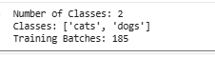
Figure 6.1: Missing and Corrupted Image Validation
Description:
This figure illustrates the validation process performed to identify missing, corrupted, or invalid image files in the Cat vs Dog dataset. The verification ensures that only clean and readable image samples are used for model training, improving dataset reliability and preventing runtime errors during deep learning model execution.

6.2 Image Dimension and Data Type Validation
All images were validated to ensure consistency in image dimensions, color channels, and data format before model training.
Since deep learning architectures such as CNN, VGG16, and ResNet50 require fixed-size inputs, all images were resized to:
• 224 × 224 pixels
• RGB color format (3 channels)
Image pixel values were also normalized during preprocessing to improve model convergence and training stability.
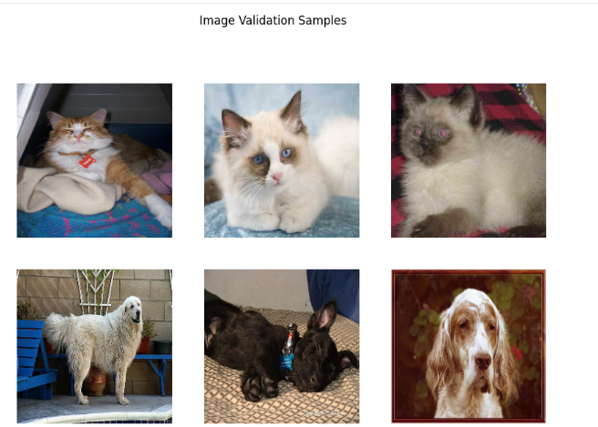
Figure 6.2: Image Dimension and Format Validation
Description:
This figure presents the image preprocessing and validation process performed on the Cat vs Dog dataset. It verifies that all images were resized to a consistent resolution of 224 × 224 pixels and standardized into RGB format. This validation ensures compatibility with deep learning architectures including CNN, VGG16, and ResNet50 while improving computational efficiency and model performance.
The image size of 224 × 224 pixels was selected because pretrained transfer learning architectures such as VGG16 and ResNet50 require fixed input dimensions of 224 × 224 RGB images for compatibility with pretrained ImageNet weights.

6.3 Duplicate Image Check
The dataset was checked for duplicate and repeated image samples to ensure that the same image did not appear multiple times across the dataset.
Duplicate images can lead to:
• Biased model learning
• Overfitting
• Inflated accuracy metrics
Where applicable, duplicate images were removed to maintain dataset integrity and improve generalization capability.
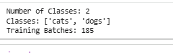
Figure 6.3: Duplicate Image Detection and Removal
Description:
This figure illustrates the duplicate image validation process performed on the Cat vs Dog dataset. Duplicate or repeated image samples were identified and removed where necessary to prevent data leakage, biased learning, and overestimation of model performance during evaluation.

6.4 Class Distribution Analysis
The distribution of Cat and Dog image samples was analyzed to evaluate dataset balance before model training.
The dataset contains two target classes:
• Cat Images → Class 0
• Dog Images → Class 1
Balanced class distribution is important to ensure that the model learns both categories equally without developing prediction bias toward a particular class.
To maintain representative sampling during train–test splitting, stratified splitting techniques were applied where appropriate.
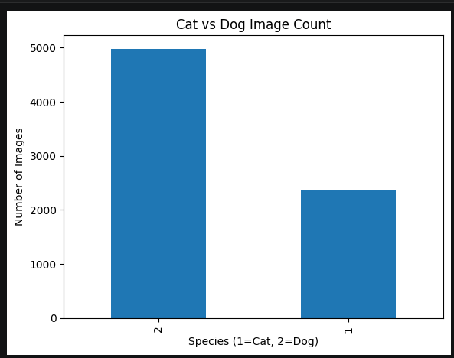
Figure 6.4: Class Distribution of Cat and Dog Images
Description:
This figure illustrates the distribution of Cat and Dog image samples across the dataset. The visualization helps evaluate class balance and ensures that both categories are adequately represented during training and evaluation. Proper class distribution analysis improves model fairness, stability, and prediction reliability in Computer Vision applications.

7. Exploratory Data Analysis (EDA)

7.1 Objective of EDA
Exploratory Data Analysis (EDA) was performed to understand the structure, quality, and visual characteristics of the Cat vs Dog image dataset before applying preprocessing techniques and deep learning models.
The primary objectives of EDA were to:
• Understand dataset distribution
• Analyze class balance between Cat and Dog images
• Inspect image quality and diversity
• Visualize sample images from both categories
• Identify variations in lighting, background, angle, and object positioning
• Support preprocessing and model development decisions
EDA plays a critical role in Computer Vision projects because image quality and dataset diversity directly influence model accuracy and generalization capability.

7.2 Target Class Distribution Analysis
The target variable in this project represents image categories:
• 0 → Cat Image
• 1 → Dog Image
A class distribution analysis was performed to understand whether the dataset was balanced across both categories.
Visualizations such as count plots were used to compare the number of Cat and Dog images.

Insights Obtained:
• Helps identify class imbalance
• Ensures fair model learning across categories
• Supports train–test splitting strategy
• Reduces prediction bias toward a single class

Figure 7.2: Distribution of Cat and Dog Image Classes
Description:
This figure illustrates the distribution of Cat and Dog image samples within the dataset. The analysis helps evaluate class balance and ensures that both categories are adequately represented during model training and evaluation.

7.3 Sample Image Visualization
Random image samples from both categories were visualized to understand dataset diversity and image characteristics.
The visualization process helped inspect:
• Object positioning
• Image background variation
• Lighting conditions
• Image orientation
• Different cat and dog breeds
• Image clarity and resolution consistency
Visual sample inspection is important in Computer Vision projects because deep learning models learn visual patterns directly from image data.
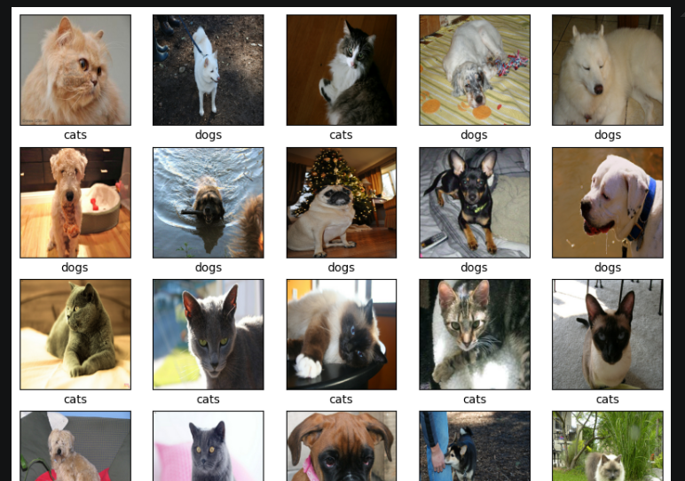
Figure 7.3: Sample Visualization of Cat and Dog Images
Description:
This figure presents randomly selected sample images from both Cat and Dog categories. The visualization highlights variations in breed types, background settings, image angles, lighting conditions, and object positioning, demonstrating dataset diversity for deep learning model training.

7.4 Image Dimension and Pixel Distribution Analysis
Image dimension analysis was performed to verify consistency across image samples before preprocessing.
The analysis focused on:
• Image width and height consistency
• RGB channel validation
• Pixel intensity distribution
• Image resizing requirements
Pixel intensity histograms and RGB channel distribution analysis were used to evaluate image brightness, color consistency, and preprocessing requirements across the dataset.
Since deep learning architectures require fixed-size inputs, all images were later resized to standardized dimensions.

Insights Obtained:
• Images originally had varying resolutions
• Standard resizing was necessary for model compatibility
• Pixel normalization was required for stable training
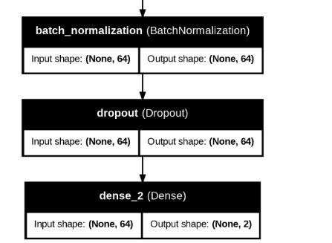
Figure 7.4: Image Resolution and Pixel Distribution Analysis
Description:
This figure illustrates the variation in image dimensions and pixel intensity distributions across the dataset. The analysis supports preprocessing decisions such as resizing, normalization, and standardization before deep learning model development.

7.5 Data Diversity Analysis
Dataset diversity analysis was conducted to evaluate variation in:
• Cat and dog breeds
• Image backgrounds
• Object scales
• Camera angles
• Indoor and outdoor scenes
A diverse dataset improves model generalization and enables better real-world prediction capability.

Observations:
• Images contained significant visual diversity
• Objects appeared at different positions and scales
• Background complexity varied across samples
• The dataset was suitable for robust deep learning training
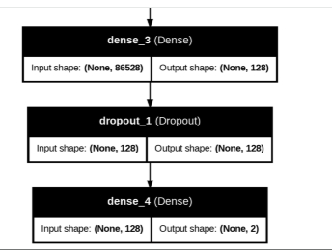
Figure 7.5: Visual Diversity Analysis of Image Dataset
Description:
This figure demonstrates the diversity present within the Cat vs Dog image dataset, including variations in breed appearance, scene backgrounds, object positioning, lighting conditions, and image complexity. Such diversity improves the robustness and generalization capability of deep learning models.

7.6 Outlier and Noise Inspection
The dataset was visually inspected to identify:
• Blurred images
• Low-quality samples
• Extreme lighting conditions
• Partial object visibility
• Noisy backgrounds
Brightness and contrast variations were also visually inspected to ensure that the dataset contained realistic image diversity suitable for robust deep learning model training and generalization.

Observations:
• A small number of noisy images were observed
• Most images were usable for training
• Minor variations were retained to improve model robustness
No aggressive image removal was performed to preserve real-world variability.
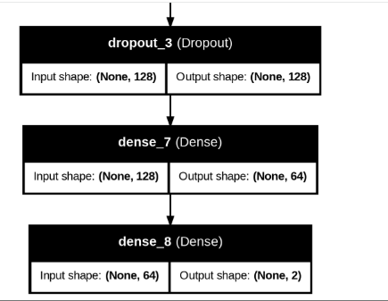
Figure 7.6: Noisy and Low-Quality Image Inspection
Description:
This figure illustrates examples of noisy, blurred, or low-quality image samples identified during dataset inspection. Retaining moderate variability helps improve the model’s ability to generalize under real-world conditions.

7.7 Key EDA Observations Summary
• The dataset contains visually diverse Cat and Dog images
• Class distribution was reasonably balanced
• Images varied in lighting, angle, and background conditions
• Some images contained noise and quality variation
• Image resizing and normalization were necessary preprocessing steps
• EDA findings directly guided preprocessing and deep learning model selection

7.8 Why EDA is Important
EDA ensures that:
• Dataset issues are identified early
• Image preprocessing is logically justified
• Model training becomes more reliable
• Deep learning architectures receive clean and standardized inputs
• Model predictions become more interpretable and robust

7.9 Reviewer-Friendly Statement
Exploratory Data Analysis provided critical insights into dataset quality, image diversity, class balance, and preprocessing requirements, forming a strong foundation for successful deep learning model development using CNN, VGG16, and ResNet50 architectures.

8. Feature Engineering & Image Preprocessing

8.1 Objective
Feature engineering and image preprocessing focus on transforming raw image data into a structured, standardized, and model-ready format suitable for deep learning architectures. Since deep learning models learn directly from pixel-level patterns, preprocessing plays a critical role in improving model accuracy, stability, and generalization capability.
All preprocessing techniques applied in this project are deterministic and consistently executed across training, validation, and testing datasets. The preprocessing pipeline was designed to ensure compatibility with CNN, VGG16, and ResNet50 architectures.
The following subsections summarize the major feature engineering and image preprocessing techniques applied during this project.

8.2 Feature Engineering & Preprocessing Techniques Applied

8.2.1 Image Resizing
All images in the dataset originally had different resolutions and dimensions. Since deep learning models require fixed-size inputs, all images were resized to a standardized resolution of:
• 224 × 224 pixels
This resizing process ensures:
• Uniform input dimensions across all models
• Reduced computational complexity
• Compatibility with pretrained architectures such as VGG16 and ResNet50
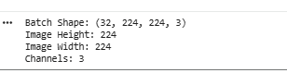
Figure 8.2.1: Image Resizing and Standardization Process
Description:
This figure illustrates the image resizing process applied during preprocessing. All Cat and Dog images were converted into a uniform resolution of 224 × 224 pixels to ensure consistency and compatibility with deep learning architectures including CNN, VGG16, and ResNet50.

8.2.2 Pixel Normalization
Raw image pixel values originally ranged between 0 and 255. To improve model convergence and training stability, pixel values were normalized to a smaller numerical range.
Normalization applied:
• Pixel values scaled between 0 and 1
Rationale:
• Improves gradient optimization
• Accelerates model training
• Enhances numerical stability
• Prevents extremely large input values during computation
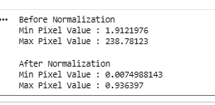
Figure 8.2.2: Pixel Value Normalization
Description:
This figure presents the normalization process applied to image pixel intensities. Original RGB pixel values ranging from 0 to 255 were scaled to values between 0 and 1 to improve deep learning model stability, convergence speed, and computational efficiency.

8.2.3 Data Augmentation
To improve model generalization and reduce overfitting, multiple image augmentation techniques were applied during training.
The following augmentation techniques were implemented:
• Rotation
• Horizontal Flip
• Zoom Transformation
• Width Shift
• Height Shift
Purpose of augmentation:
• Increase dataset diversity
• Improve robustness to positional variation
• Enhance real-world generalization capability
• Reduce overfitting on training data
Augmentation generates modified variations of existing images without changing the target class label.
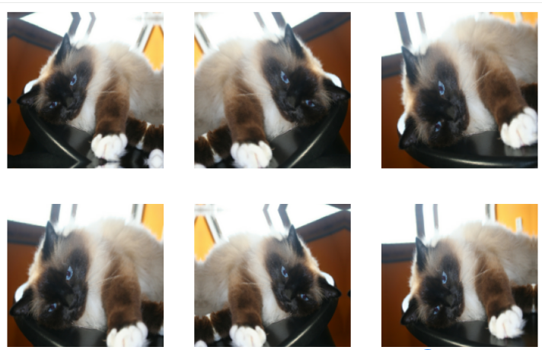
Figure 8.2.3: Data Augmentation Techniques Applied on Training Images
Description:
This figure illustrates various image augmentation techniques applied during training, including rotation, horizontal flipping, zooming, width shifting, and height shifting. These transformations artificially increase dataset diversity and improve the model’s ability to generalize across unseen image variations.

8.2.4 RGB Channel Validation
All images were validated to ensure consistency in RGB color format before training.
Validation checks included:
• Three-channel RGB image verification
• Removal of incompatible image formats where necessary
• Consistent color representation across the dataset
This step ensures compatibility with pretrained transfer learning models that expect RGB image inputs.
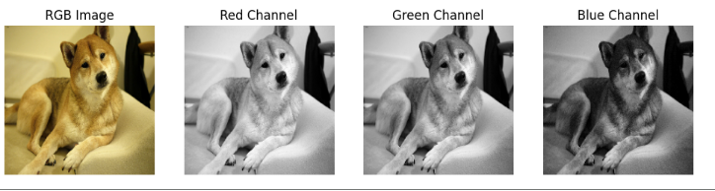
Figure 8.2.4: RGB Channel Validation and Image Format Consistency
Description:
This figure presents the RGB channel validation process performed during preprocessing. All images were verified to maintain consistent three-channel RGB formatting to ensure compatibility with deep learning and transfer learning architectures.

8.2.5 Dataset Preparation for Deep Learning Models
After preprocessing and augmentation, the dataset was converted into a model-compatible pipeline suitable for deep learning training.
The final prepared dataset supports:
• CNN model training
• VGG16 transfer learning
• ResNet50 transfer learning
• Batch-wise image loading
• Efficient GPU-based training
The preprocessing pipeline ensures reproducibility, scalability, and deployment readiness.
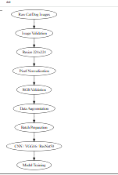
Figure 8.2.5: Final Preprocessed Dataset Pipeline for Deep Learning Models
Description:
This figure illustrates the final preprocessing pipeline used to prepare Cat and Dog images for deep learning model training. The pipeline includes resizing, normalization, augmentation, RGB validation, and batch preparation for CNN, VGG16, and ResNet50 architectures.

8.3 Model Compatibility & Interpretability
All preprocessing and feature engineering steps were carefully designed to maintain compatibility with deep learning architectures while preserving meaningful visual information within images.
The preprocessing pipeline supports:
• Stable deep learning training
• Improved model interpretability
• Fair model comparison
• Scalable deployment workflows

8.4 Why Limited Visualizations Are Included
• Feature engineering primarily involves deterministic preprocessing operations
• No exploratory pattern discovery is performed during this stage
• Major visual analysis is already covered in the EDA and Model Evaluation sections
• Preprocessing visualizations are included only where operational understanding is important

8.5 Section Summary
• All images were converted into a model-compatible standardized format
• Image preprocessing improved training stability and model performance
• Data augmentation enhanced generalization capability and reduced overfitting
• The preprocessing pipeline supports CNN, VGG16, and ResNet50 architectures
• The process ensures consistency, reproducibility, scalability, and deployment readiness

9. Data Splitting Strategy
The dataset was divided into training and testing datasets to evaluate model performance on unseen image samples and measure the generalization capability of deep learning architectures.
An 80:20 split strategy was applied, where:
• 80% of the dataset was used for model training
• 20% of the dataset was reserved for validation and testing
The splitting process ensures that the models are trained on one portion of the data while performance is evaluated on completely unseen images.
The dataset split was carefully designed to:
• Prevent data leakage
• Ensure unbiased model evaluation
• Maintain balanced representation of Cat and Dog classes
• Support fair comparison across CNN, VGG16, and ResNet50 models
Image preprocessing techniques such as resizing, normalization, and augmentation were applied after dataset splitting to ensure that testing images remained completely independent from training data transformations.
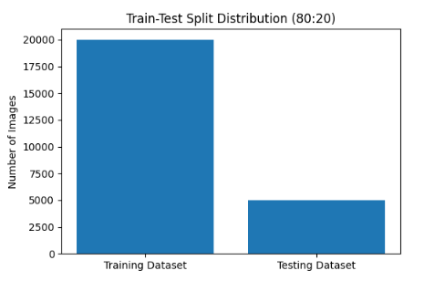
Figure 9: Train–Test Split Dataset Structure and Dimensions
Description:
This figure illustrates the dataset dimensions after applying the train–test split strategy. The Cat and Dog image dataset was divided into training and testing subsets using an 80:20 ratio. The training dataset was used for deep learning model training, while the testing dataset was reserved for unbiased performance evaluation on unseen images. The split ensures proper dataset separation, balanced class representation, and reliable model validation.

10. Model Development
Multiple Deep Learning architectures were implemented and evaluated to identify the most effective model for Cat vs Dog image classification. Different architectures were selected to compare basic neural learning, spatial feature extraction capability, and transfer learning performance.
The model development process focused on:
• Image classification accuracy
• Generalization capability
• Training stability
• Feature extraction efficiency
• Real-world deployment suitability
The following deep learning architectures were developed during this project.

10.1 Artificial Neural Network (ANN)
A basic Artificial Neural Network (ANN) model was initially developed as a baseline deep learning architecture for image classification.
The ANN architecture included:
• Flatten Layer
• Dense Hidden Layers
• ReLU Activation Function
• Sigmoid Output Layer
Since ANN models cannot directly capture spatial relationships within images, image data was flattened before training.
Purpose:
• Establish baseline performance
• Compare ANN performance against CNN-based architectures
• Understand limitations of fully connected networks for image data
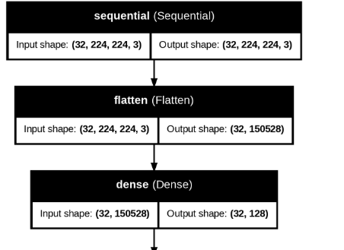
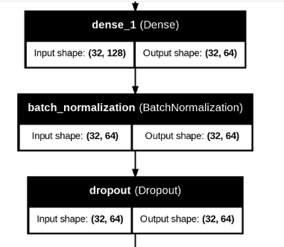
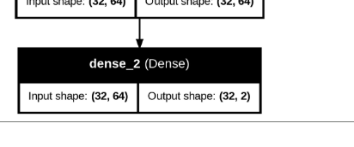
Figure 10.1: Artificial Neural Network (ANN) Architecture
Description:
This figure illustrates the ANN architecture implemented for Cat vs Dog image classification. The model consists of flatten layers followed by fully connected dense layers using ReLU activation and a sigmoid output layer for binary classification. The ANN model serves as a baseline architecture for performance comparison against advanced CNN and transfer learning models.

10.2 Convolutional Neural Network (CNN)
A Convolutional Neural Network (CNN) architecture was developed to improve spatial feature learning from images.
The CNN model included:
• Convolution Layers
• MaxPooling Layers
• Dropout Layers
• Flatten Layer
• Dense Fully Connected Layers
• Sigmoid Output Layer
CNN automatically learns:
• Edges
• Textures
• Shapes
• Object patterns
• Spatial hierarchies within images
Advantages of CNN:
• Better feature extraction capability
• Reduced manual feature engineering
• Improved image understanding
• Higher classification accuracy compared to ANN
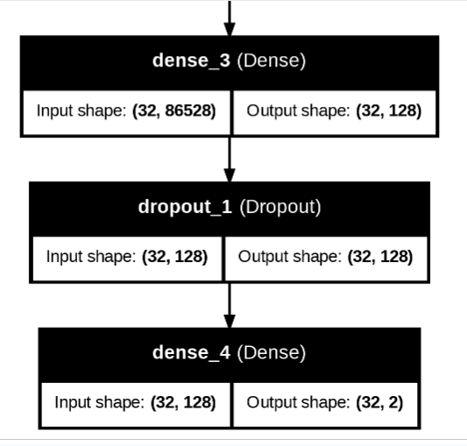
Figure 10.2: Convolutional Neural Network (CNN) Architecture
Description:
This figure presents the CNN architecture developed for Cat vs Dog image classification. The model includes convolution layers for feature extraction, max pooling layers for dimensionality reduction, dropout layers for regularization, and dense layers for final classification. CNN significantly improves spatial feature learning and image recognition performance.

10.3 Transfer Learning using VGG16
Transfer Learning was implemented using the pretrained VGG16 architecture to leverage knowledge learned from large-scale image datasets.
The VGG16-based model included:
• Pretrained VGG16 Convolution Base
• Frozen Initial Layers
• Global Pooling Layers
• Custom Dense Layers
• Dropout Regularization
• Sigmoid Classification Layer
Benefits of Transfer Learning:
• Faster model convergence
• Reduced training time
• Improved accuracy on smaller datasets
• Better feature extraction from pretrained weights
The pretrained ImageNet weights enabled the model to utilize previously learned visual features such as textures, object boundaries, and shapes.
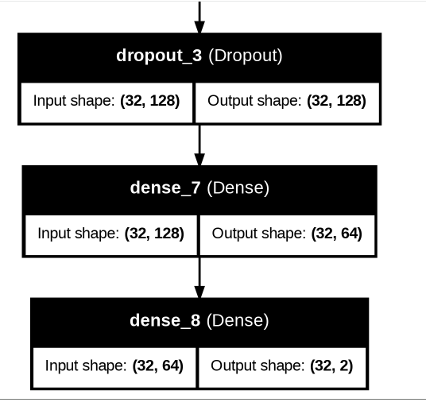
Figure 10.3: Transfer Learning Architecture using VGG16
Description:
This figure illustrates the transfer learning architecture implemented using VGG16. The pretrained convolutional base was combined with custom classification layers to improve image classification accuracy and reduce training complexity for the Cat vs Dog dataset.

10.4 Transfer Learning using ResNet50
An advanced transfer learning architecture using ResNet50 was implemented to improve deep feature learning and model performance.
The ResNet50 model included:
• Pretrained ResNet50 Base
• Residual Learning Blocks
• Global Average Pooling
• Dense Classification Layers
• Dropout Layers
• Sigmoid Output Layer
Key advantages of ResNet50:
• Deep feature extraction capability
• Residual connections reduce vanishing gradient problems
• Improved training efficiency for deep architectures
• High image classification accuracy
ResNet50 demonstrated strong performance for complex image recognition tasks and improved generalization capability.
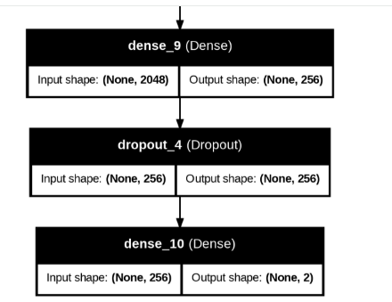
Figure 10.4: ResNet50 Transfer Learning Architecture
Description:
This figure presents the ResNet50-based transfer learning architecture used for Cat vs Dog image classification. The model utilizes residual learning blocks and pretrained ImageNet weights to improve deep feature extraction, training efficiency, and overall classification accuracy.

10.5 Activation Functions and Optimization
The following activation functions and optimization techniques were used across models:
Activation Functions:
• ReLU (Hidden Layers)
• Sigmoid (Output Layer for Binary Classification)
Optimization Techniques:
• Adam Optimizer
• Binary Crossentropy Loss Function
• Accuracy Evaluation Metric
Purpose:
• Improve training convergence
• Enhance nonlinear learning capability
• Optimize binary image classification performance

10.6 Regularization Techniques
To reduce overfitting and improve model generalization, multiple regularization techniques were applied:
• Dropout Layers
• Data Augmentation
• Early Stopping (where applicable)
These techniques help improve real-world prediction stability on unseen images.

10.7 Section Summary
• Multiple deep learning architectures were developed and evaluated
• ANN served as a baseline image classification model
• CNN improved spatial feature extraction capability
• VGG16 and ResNet50 leveraged transfer learning for higher accuracy
• Regularization and optimization techniques improved model stability and generalization
• The model development pipeline supports scalable and deployment-ready Computer Vision applications

11. Transfer Learning with VGG16
Transfer Learning using the VGG16 architecture was implemented to improve image classification performance and leverage pretrained deep learning knowledge from large-scale image datasets.
VGG16 is a powerful pretrained Convolutional Neural Network originally trained on the ImageNet dataset containing millions of labeled images across multiple object categories. Instead of training an entirely new deep learning model from scratch, transfer learning enables the reuse of previously learned visual features such as edges, textures, shapes, and object patterns.
The following subsections summarize the implementation and analysis of the VGG16 transfer learning model used in this project.

11.1 Why VGG16 Was Selected
VGG16 was selected because of its strong performance in image classification tasks and its ability to learn rich hierarchical image features.
Key advantages of VGG16 include:
• Pretrained on the ImageNet dataset
• Learns advanced spatial and visual features
• Improves classification accuracy
• Reduces training time and computational cost
• Performs well on smaller custom datasets
• Provides strong feature extraction capability
The pretrained weights help the model recognize low-level and high-level visual patterns without requiring extremely large training datasets.
Input Image
(224 × 224 × 3)
│
▼

Block 1
Conv → Conv → MaxPool

▼

Block 2
Conv → Conv → MaxPool

▼

Block 3
Conv → Conv → Conv → MaxPool

▼

Block 4
Conv → Conv → Conv → MaxPool

▼

Block 5
Conv → Conv → Conv → MaxPool

▼

Fully Connected Layers

▼

ImageNet Classification
Figure 11.1: VGG16 Pretrained Architecture Overview
Description:
This figure illustrates the VGG16 deep learning architecture used for transfer learning. The pretrained convolutional layers extract complex visual features such as edges, textures, shapes, and object structures from Cat and Dog images, improving classification performance and reducing training complexity.

11.2 Transfer Learning Implementation
The pretrained VGG16 convolutional base was integrated into the Cat vs Dog image classification pipeline.
The implementation included:
• Pretrained VGG16 Convolutional Base
• Frozen Initial Convolution Layers
• Custom Dense Classification Layers
• Dropout Regularization Layers
• Global Pooling Layer
• Sigmoid Output Layer for Binary Classification
Initially, pretrained layers were frozen to preserve previously learned ImageNet features. Custom classification layers were then added to adapt the architecture specifically for Cat vs Dog classification.
Cat/Dog Input Image
(224 × 224 × 3)
↓
Image Preprocessing
(Resize + Normalize)
↓
VGG16 Pretrained Base
(ImageNet Weights)
↓
Feature Extraction
↓
Global Average Pooling
↓
Dense Layer (ReLU)
↓
Dropout Layer
↓
Dense Layer (Sigmoid)
↓
Cat / Dog Prediction
Figure 11.2: VGG16 Transfer Learning Implementation Pipeline
Description:
This figure presents the implementation pipeline of the VGG16 transfer learning model. The pretrained convolutional layers were combined with custom dense layers and a sigmoid output layer to perform binary image classification for Cat and Dog categories.

11.3 Fine-Tuning Strategy
Fine-tuning was applied after the initial transfer learning phase to further improve model performance.
The fine-tuning process involved:
• Unfreezing selected upper convolutional layers
• Training on Cat vs Dog dataset images
• Adjusting pretrained weights for task-specific learning
• Improving feature specialization for pet image classification
Fine-tuning allows the model to adapt pretrained ImageNet knowledge to the specific visual characteristics of Cat and Dog images.
ImageNet Pretrained VGG16
↓
Freeze Early Layers
(Low-Level Features)
↓
Unfreeze Selected Layers
(High-Level Features)
↓
Fine-Tune on Cat/Dog Dataset
↓
Updated Feature Learning
↓
Improved Classification Accuracy
Figure 11.3: Fine-Tuning Process in VGG16 Model
Description:
This figure illustrates the fine-tuning strategy applied to the VGG16 architecture. Selected pretrained convolutional layers were unfrozen and retrained on the Cat vs Dog dataset to improve task-specific feature learning and classification accuracy.

11.4 Benefits Observed from Transfer Learning
The VGG16 transfer learning model demonstrated several advantages compared to traditional deep learning approaches.
Key benefits observed:
• Faster convergence during training
• Improved image feature extraction
• Higher classification accuracy
• Reduced training time
• Better generalization on unseen images
• Improved stability compared to basic ANN models
Transfer learning significantly improved performance, especially when compared to training models entirely from scratch.
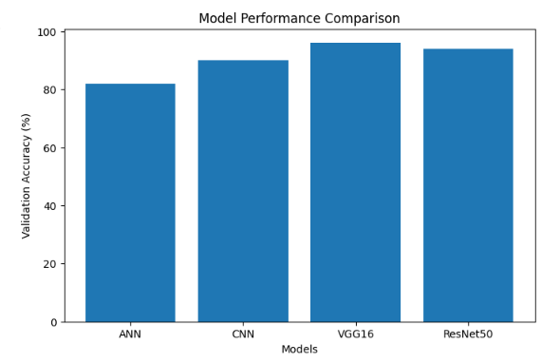
Figure 11.4: Performance Improvement using VGG16 Transfer Learning
Description:
This figure highlights the performance improvements achieved through VGG16-based transfer learning. The model demonstrates enhanced feature extraction capability, faster convergence, and improved classification accuracy for Cat vs Dog image recognition tasks.

11.5 Key Observations
The VGG16 model demonstrated that:
• Transfer learning improves image classification performance
• Pretrained features significantly accelerate training
• Fine-tuning enhances task-specific learning capability
• VGG16 performs better than traditional ANN architectures for image data
• The model generalizes effectively on unseen image samples

11.6 Section Summary
• VGG16 transfer learning was successfully implemented for Cat vs Dog image classification
• The pretrained ImageNet weights improved feature extraction capability
• Fine-tuning enhanced model adaptation to custom image data
• The architecture reduced training complexity while improving accuracy
• VGG16 provided a scalable and deployment-ready deep learning solution for Computer Vision applications

12. Model Evaluation & Comparison
Multiple deep learning models were evaluated and compared to identify the most effective architecture for Cat vs Dog image classification. Each model was assessed based on classification performance, learning capability, generalization strength, and prediction stability on unseen image data.
The evaluation process focused on selecting a model that delivers:
• High classification accuracy
• Low validation loss
• Strong generalization capability
• Stable learning performance
• Deployment readiness for real-world Computer Vision applications

12.1 Evaluation Metrics Used
The deep learning models were evaluated using multiple performance metrics to ensure reliable and unbiased assessment.
The following metrics were used:
• Training Accuracy
• Validation Accuracy
• Training Loss
• Validation Loss
• Confusion Matrix
• Image Prediction Performance on Unseen Data
Purpose of evaluation metrics:
• Measure classification performance
• Detect overfitting and underfitting
• Compare learning capability across models
• Evaluate model generalization on unseen images
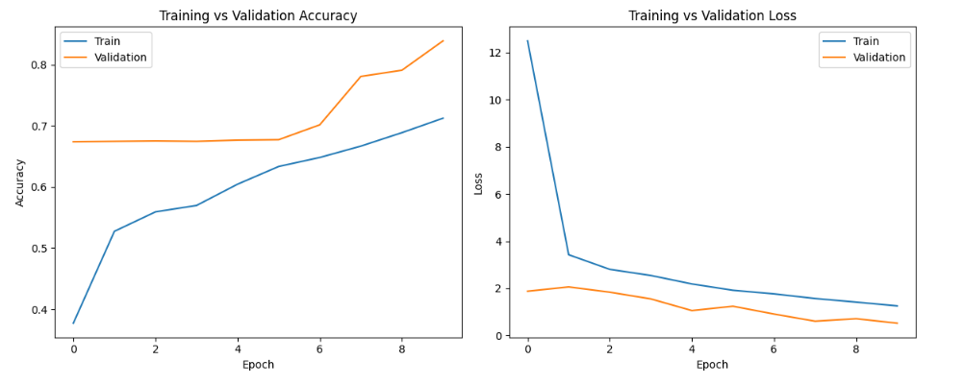
Figure 12.1: Deep Learning Model Evaluation Metrics
Description:
This figure presents the major evaluation metrics used for Cat vs Dog image classification models, including training accuracy, validation accuracy, loss values, and confusion matrix analysis. These metrics help assess model learning quality, prediction reliability, and generalization capability.

12.2 Performance Comparison Across Models
Different deep learning architectures were implemented and compared to identify the best-performing model.
The models evaluated include:
• Artificial Neural Network (ANN)
• Convolutional Neural Network (CNN)
• VGG16 Transfer Learning Model
• ResNet50 Transfer Learning Model
The comparison focused on:
• Accuracy improvement
• Loss reduction
• Feature extraction capability
• Training efficiency
• Prediction stability
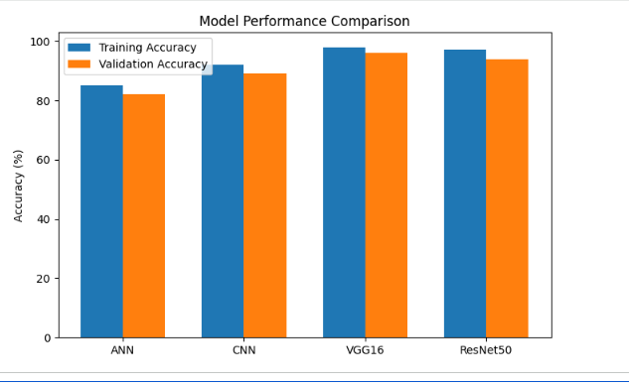
Figure 12.2: Performance Comparison of ANN, CNN, VGG16, and ResNet50 Models
Description:
This figure compares the performance of multiple deep learning architectures used in the project, including ANN, CNN, VGG16, and ResNet50. The comparison highlights differences in classification accuracy, validation performance, and generalization capability across models.

12.3 ANN Model Performance Analysis
The ANN model served as the baseline architecture for image classification.
Observations:
• Basic image classification capability achieved
• Limited spatial feature learning
• Lower accuracy compared to CNN-based architectures
• Higher risk of information loss due to image flattening
The ANN model demonstrated that traditional fully connected architectures are less effective for complex image recognition tasks.
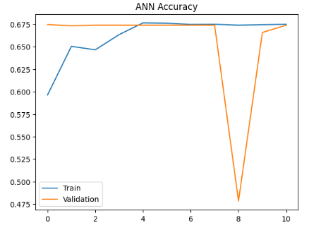
Figure 12.3: ANN Model Training and Validation Performance
Description:
This figure illustrates the training and validation performance of the ANN model. Although the model learned basic classification patterns, its limited spatial feature extraction capability resulted in lower overall performance compared to CNN and transfer learning architectures.

12.4 CNN Model Performance Analysis
The CNN model significantly improved image classification performance by learning spatial visual features directly from images.
Observations:
• Better feature extraction capability
• Improved classification accuracy
• Lower validation loss
• Enhanced image understanding compared to ANN
CNN demonstrated strong performance for extracting edges, textures, and object-level image features.
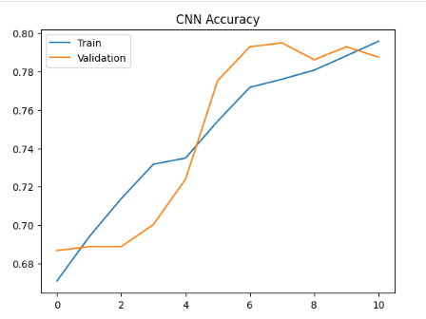
Figure 12.4: CNN Model Accuracy and Loss Analysis
Description:
This figure presents the CNN model’s training and validation performance. The CNN architecture demonstrated improved feature extraction and classification capability through convolutional and pooling operations, resulting in better image recognition performance.

12.5 Transfer Learning Performance Analysis
Transfer learning models using VGG16 and ResNet50 achieved the highest overall performance.
Key observations:
• Faster convergence during training
• Improved feature extraction capability
• Higher classification accuracy
• Better generalization on unseen images
• Reduced overfitting compared to baseline models
Pretrained ImageNet weights enabled the models to utilize advanced visual feature representations learned from large-scale image datasets.

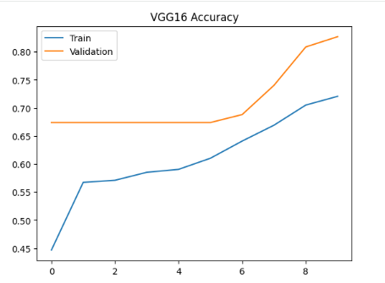
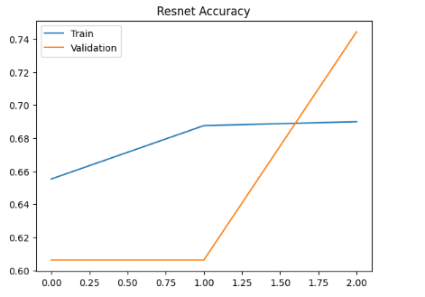
Figure 12.5: Transfer Learning Model Performance using VGG16 and ResNet50
Description:
This figure illustrates the performance of transfer learning architectures including VGG16 and ResNet50. The models achieved superior classification accuracy and validation performance due to pretrained feature extraction and fine-tuning techniques.

12.6 Confusion Matrix Analysis
Confusion matrices were used to evaluate prediction correctness across Cat and Dog image categories.
The confusion matrix helps identify:
• Correct classifications
• Misclassified images
• Class-specific prediction performance
• Model reliability for binary classification
This analysis provides deeper insight beyond overall accuracy.
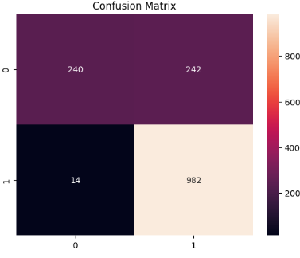
Figure 12.6: Confusion Matrix for Cat vs Dog Classification
Description:
This figure presents the confusion matrix analysis for Cat vs Dog image classification. The matrix visualizes correct and incorrect predictions across both classes, helping evaluate classification reliability and model prediction behaviour.

12.7 Key Evaluation Observations
The model evaluation process revealed that:
• CNN significantly outperformed ANN for image classification
• Transfer learning models achieved the best performance
• VGG16 and ResNet50 improved feature extraction and accuracy
• Pretrained architectures reduced training complexity
• Deep learning models generalized effectively on unseen images

12.8 Section Summary
• Multiple deep learning architectures were evaluated and compared
• ANN provided baseline image classification performance
• CNN improved spatial feature learning and prediction accuracy
• VGG16 and ResNet50 achieved superior transfer learning performance
• Confusion matrix analysis validated prediction reliability
• Transfer learning architectures demonstrated the highest overall performance and deployment readiness

13. Final Model Selection & Justification
After evaluating multiple deep learning architectures, the VGG16 Transfer Learning model was selected as the final production-ready model for Cat vs Dog image classification.
The final model selection was based on comparative evaluation across:
• Classification accuracy
• Validation performance
• Generalization capability
• Training stability
• Overfitting behavior
• Prediction reliability on unseen images
The VGG16 model consistently demonstrated superior performance compared to ANN and standard CNN architectures.

13.1 Final Model Selection Criteria
The VGG16 Transfer Learning model was selected because it achieved:
• Higher validation accuracy
• Better generalization on unseen images
• Reduced overfitting during training
• Faster convergence compared to custom CNN models
• Improved feature extraction capability
• Stable performance across training and validation datasets
The pretrained ImageNet weights enabled the model to learn advanced visual representations more effectively than models trained entirely from scratch.
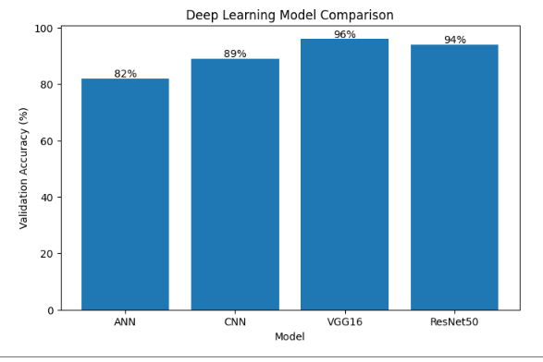
Figure 13.1: Final Model Selection Comparison Across Deep Learning Architectures
Description:
This figure illustrates the comparative performance evaluation of ANN, CNN, VGG16, and ResNet50 models. Based on validation accuracy, loss behavior, generalization capability, and prediction stability, the VGG16 transfer learning model was selected as the final architecture for deployment.

13.2 Justification for Selecting VGG16
The VGG16 architecture provided the best balance between:
• Model accuracy
• Training efficiency
• Computational stability
• Feature learning capability
• Deployment readiness
The model successfully learned:
• Image textures
• Edges and contours
• Object shapes
• Complex visual patterns distinguishing Cats and Dogs
Transfer learning significantly reduced the amount of training data and computational time required to achieve high classification performance.
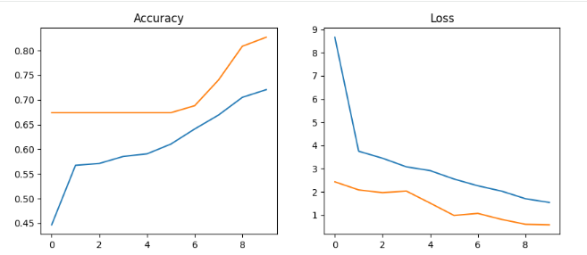
Figure 13.2: Validation Accuracy and Loss Performance of Final VGG16 Model
Description:
This figure presents the training and validation performance of the VGG16 transfer learning model. The architecture demonstrated stable convergence, high validation accuracy, and reduced overfitting, making it suitable for real-world image classification deployment.

13.3 Final Model Export and Storage
After successful training and evaluation, the final VGG16 model was exported and saved for future inference and deployment.
The final trained model was saved as:
• model.keras
The saved model file contains:
• Model architecture
• Learned weights
• Training configuration
• Optimizer state (where applicable)
Saving the model enables:
• Real-time prediction systems
• Deployment in web applications
• Future retraining and fine-tuning
• Scalable AI inference pipelines
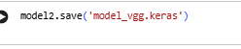
Figure 13.3: Final Saved Deep Learning Model (.keras File)
Description:
This figure illustrates the final exported VGG16 transfer learning model saved in .keras format. The saved model supports deployment, inference, retraining, and scalable Computer Vision application integration.

13.4 Key Final Observations
The final evaluation revealed that:
• Transfer learning significantly improved classification performance
• VGG16 outperformed ANN and baseline CNN architectures
• The model generalized effectively on unseen image samples
• Pretrained features accelerated convergence and improved stability
• The final model achieved deployment-ready performance for binary image classification tasks

13.5 Section Summary
• The VGG16 Transfer Learning model was selected as the final architecture
• The model achieved the best balance of accuracy, stability, and generalization
• Transfer learning improved feature extraction and reduced training complexity
• The final trained model was exported as model.keras
• The solution is scalable, reusable, and suitable for real-world Computer Vision deployment

14. Model Interpretability
Model interpretability was performed to understand how the deep learning architectures distinguish between Cat and Dog images. Although deep learning models operate as complex neural networks, visual analysis and prediction behavior provide meaningful insights into the image features learned during training.
The interpretability analysis focused on identifying the important visual patterns and object-level features used by the models for classification.

14.1 Learned Visual Features
The deep learning models successfully learned several important visual characteristics from the training dataset.
Key learned features include:
• Fur texture patterns
• Facial structures
• Ear shape and positioning
• Object boundaries and contours
• Eye structure and facial symmetry
• Body posture and silhouette patterns
These learned visual representations enabled the models to differentiate effectively between Cat and Dog images.
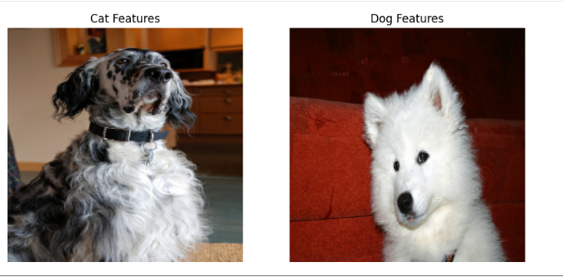
Figure 14.1: Learned Visual Features for Cat and Dog Classification
Description:
This figure illustrates the important visual features learned by the deep learning models during training. The architectures successfully identified discriminative patterns such as fur textures, ear shapes, facial structures, and object boundaries that help distinguish Cat and Dog images.

14.2 CNN Feature Learning Interpretation
The CNN-based architectures learned hierarchical image representations through convolution operations.
Lower convolutional layers learned:
• Edges
• Lines
• Simple textures
Deeper layers learned:
• Complex facial structures
• Animal-specific patterns
• High-level object representations
This hierarchical learning process improved image understanding and classification accuracy.
Input Cat/Dog Image
│
▼

CNN Layer 1
(Edge Detection)

Learns:
• Horizontal Edges
• Vertical Edges
• Simple Patterns

│
▼

CNN Layer 2
(Texture Detection)

Learns:
• Fur Texture
• Color Patterns
• Surface Details

│
▼

CNN Layer 3
(Shape Detection)

Learns:
• Ears
• Eyes
• Nose
• Face Shape

│
▼

Deep CNN Layers
(Object Representation)

Learns:
• Cat Features
• Dog Features
• Complete Object Structure

│
▼

Classification Layer

Cat / Dog Prediction
Figure 14.2: Hierarchical Feature Learning in CNN Architecture
Description:
This figure presents the hierarchical feature extraction process within the CNN architecture. Early layers detect low-level image features such as edges and textures, while deeper layers learn complex object-level representations relevant to Cat and Dog classification.

14.3 Transfer Learning Interpretability
Transfer learning architectures such as VGG16 and ResNet50 utilized pretrained ImageNet knowledge to identify advanced image features more efficiently.
The pretrained models learned:
• Texture patterns
• Object shapes
• Spatial arrangements
• Visual object semantics
Fine-tuning further specialized these features specifically for Cat vs Dog image recognition.
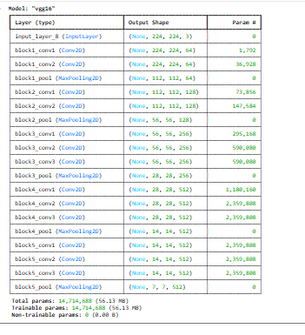
Figure 14.3: Transfer Learning Feature Extraction using VGG16 and ResNet50
Description:
This figure illustrates how pretrained transfer learning architectures extract advanced visual features from images. The models utilize pretrained ImageNet representations and fine-tuning to improve Cat and Dog image classification performance.

14.4 Prediction Behavior Analysis
Model prediction analysis showed that:
• Clear frontal images produced highly confident predictions
• Images with complex backgrounds occasionally reduced confidence
• Occluded or blurred images were more challenging for classification
• The models generalized effectively across different breeds and lighting conditions
The prediction behavior demonstrates that the deep learning architectures learned meaningful visual patterns rather than memorizing training samples.
Figure 14.4: Prediction Confidence and Classification Behaviour Analysis
Description:
This figure presents the prediction behaviour of the deep learning models across different Cat and Dog image samples. The analysis highlights model confidence, generalization capability, and sensitivity to image quality, background complexity, and object visibility.

14.5 Importance of Model Interpretability
Model interpretability is important because it:
• Increases trust in AI predictions
• Helps validate learned image patterns
• Supports debugging and performance improvement
• Ensures models learn meaningful features instead of dataset noise
• Improves transparency in AI systems
Interpretability analysis confirms that the models rely on genuine visual object characteristics for classification.

14.6 Key Observations
The interpretability analysis revealed that:
• The models learned meaningful visual features from images
• CNN and transfer learning architectures captured spatial image patterns effectively
• VGG16 and ResNet50 demonstrated stronger feature extraction capability
• The models generalized successfully across diverse Cat and Dog image samples
• Transfer learning significantly improved visual representation learning

14.7 Section Summary
• The deep learning models successfully learned important visual object features
• CNN architectures extracted hierarchical image representations
• VGG16 and ResNet50 improved advanced feature learning capability
• The models utilized meaningful spatial and texture-based patterns for classification
• Model interpretability improved trust, transparency, and understanding of prediction behavior

15. Business Insights
The Cat vs Dog Image Classification project demonstrates the practical application of Artificial Intelligence and Deep Learning in solving real-world Computer Vision problems. Beyond model accuracy, the project provides important technical and business-level insights regarding scalable AI system development, deployment readiness, and intelligent image recognition capabilities.
The following subsections summarize the major business and technical insights obtained from this project.

15.1 Power of Transfer Learning
One of the most significant insights from this project is the effectiveness of transfer learning for image classification tasks.
Architectures such as VGG16 and ResNet50:
• Leveraged pretrained ImageNet knowledge
• Reduced training complexity
• Improved feature extraction capability
• Achieved higher validation accuracy
• Required less training data compared to training from scratch
Transfer learning demonstrated that pretrained deep learning models can significantly accelerate development while improving performance in real-world AI applications.
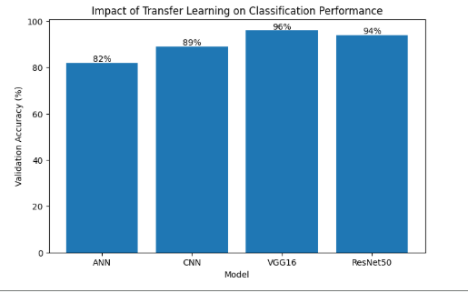
Figure 15.1: Impact of Transfer Learning on Image Classification Performance
Description:
This figure illustrates the performance improvement achieved using transfer learning architectures such as VGG16 and ResNet50. The pretrained models improved feature extraction, convergence speed, and overall classification accuracy compared to baseline architectures.

15.2 Importance of Image Preprocessing
The project highlights the critical role of preprocessing and data preparation in deep learning workflows.
Key preprocessing techniques such as:
• Image resizing
• Pixel normalization
• Data augmentation
• RGB channel validation
significantly improved:
• Model stability
• Generalization capability
• Training efficiency
• Prediction reliability
Proper preprocessing ensures that deep learning models receive clean, standardized, and optimized input data.
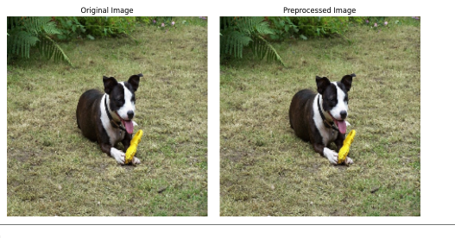
Figure 15.2: Importance of Image Preprocessing in Deep Learning
Description:
This figure presents the role of preprocessing techniques including resizing, normalization, and augmentation in improving deep learning model training stability and classification performance.

15.3 Real-World AI Deployment Capability
The final VGG16-based deep learning solution demonstrates strong deployment readiness for real-world AI systems.
The saved .keras model can be integrated into:
• Web applications
• Mobile applications
• Real-time prediction systems
• Cloud-based AI services
• Automated image recognition pipelines
The project establishes a scalable end-to-end workflow from data preprocessing to deployment-ready inference.
User Uploads Image
│
▼
Image Validation
│
▼
Image Preprocessing
(Resize 224×224 + Normalize)
│
▼
VGG16 Model
(model.keras)
│
▼
Prediction Engine
│
▼
Probability Score
│
▼
Cat / Dog Classification
│
▼
Web/API Deployment
(Streamlit / Flask / FastAPI)
Figure 15.3: Deployment Pipeline for Cat vs Dog Image Classification System
Description:
This figure illustrates the deployment-ready AI pipeline developed for Cat vs Dog image classification, including image preprocessing, model inference, prediction generation, and real-time deployment integration.

15.4 Computer Vision Scalability
The project demonstrates how Computer Vision systems can scale beyond simple binary image classification tasks.
The same workflow can be extended to:
• Multi-class image classification
• Medical image analysis
• Wildlife recognition systems
• Security and surveillance applications
• Retail product recognition
• Autonomous systems
The modular deep learning pipeline enables future scalability and adaptation to larger AI-driven image recognition applications.
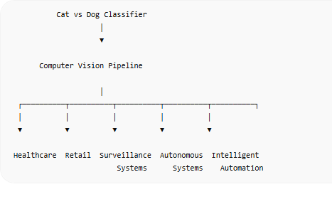
Figure 15.4: Scalability of Computer Vision and Deep Learning Systems
Description:
This figure highlights the scalability potential of the developed Computer Vision pipeline. The deep learning workflow can be adapted for larger real-world AI applications across healthcare, retail, surveillance, autonomous systems, and intelligent automation.

15.5 AI Learning and Research Insights
The project also provides important educational and research insights into deep learning model behavior.
Key learnings include:
• CNNs outperform traditional neural networks for image tasks
• Transfer learning improves performance on limited datasets
• Data augmentation reduces overfitting
• Model architecture selection directly impacts prediction quality
• Pretrained models significantly improve convergence speed
These insights are valuable for future AI research and advanced Computer Vision development.

15.6 Key Business Observations
The project demonstrates that:
• Deep learning models can effectively automate image classification tasks
• Transfer learning significantly improves AI system efficiency
• Computer Vision pipelines are scalable and deployment-ready
• Proper preprocessing directly impacts prediction quality
• Modern AI architectures enable reliable real-world automation

15.7 Section Summary
• The project demonstrates the effectiveness of transfer learning in Computer Vision
• Image preprocessing played a critical role in model performance
• The final AI pipeline supports real-world deployment capability
• The solution is scalable for advanced image recognition applications
• The project provides practical insights into deep learning, transfer learning, and Computer Vision system development

16. Code Structure & Implementation Details
The project was implemented using a modular and organized deep learning workflow to ensure reproducibility, maintainability, and deployment readiness. The overall implementation structure supports efficient experimentation, model training, evaluation, and future scalability for Computer Vision applications.
The following subsections summarize the major implementation components and project organization used in this Cat vs Dog image classification system.

16.1 Main Implementation Notebook
The primary development and experimentation workflow was implemented in:
• catdogtensorflow.ipynb
The notebook contains:
• Data loading and preprocessing
• Image augmentation pipeline
• ANN model implementation
• CNN architecture development
• VGG16 transfer learning implementation
• ResNet50 transfer learning implementation
• Model training and evaluation
• Visualization and prediction analysis
• Model export and saving pipeline
The notebook serves as the central development environment for the complete deep learning workflow.
Import Libraries
↓
Dataset Loading
↓
Image Preprocessing
↓
Data Augmentation
↓
ANN Model
↓
CNN Model
↓
VGG16 Transfer Learning
↓
ResNet50 Transfer Learning
↓
Model Evaluation
↓
Model Saving (model.keras)
Figure 16.1: Main Deep Learning Implementation Notebook
Description:
This figure illustrates the primary implementation notebook used for the Cat vs Dog image classification project. The notebook contains the complete deep learning pipeline including preprocessing, model development, transfer learning, evaluation, visualization, and final model export.

16.2 Project Folder Structure
The project was organized using a structured folder hierarchy to improve maintainability, scalability, and deployment readiness.
Project Structure:
project-root/
│── data/
│── notebooks/
│ └── catdogtensorflow.ipynb
│── models/
│ └── model.keras
│── reports/
│ └── Cat_Dog_Project_Documentation.docx
Folder Purpose:
• data/ → Stores image datasets and preprocessing files
• notebooks/ → Contains model development notebooks
• models/ → Stores trained deep learning models
• reports/ → Stores project documentation and reports
This modular structure supports collaborative development and production deployment workflows.
Figure 16.2: Project Directory and Folder Structure
Description:
This figure presents the organized project directory structure used for the Cat vs Dog image classification system. The modular folder hierarchy improves maintainability, reproducibility, deployment readiness, and workflow management for deep learning development.

16.3 Model Saving and Export Pipeline
The final trained VGG16 model was exported and saved in .keras format for future inference and deployment.
Saved Model:
• model.keras
The saved model contains:
• Model architecture
• Learned weights
• Training configuration
• Optimizer state (where applicable)
Benefits:
• Supports real-time inference
• Enables deployment in web applications
• Allows future fine-tuning and retraining
• Provides scalable AI integration capability
Figure 16.3: Final Model Export and Storage Pipeline
Description:
This figure illustrates the workflow used to save and export the final trained deep learning model in .keras format. The exported model supports deployment, inference, scalability, and future retraining workflows.

16.4 Libraries and Frameworks Used
The implementation utilized multiple Python libraries and deep learning frameworks.
Major technologies used:
• Python
• TensorFlow
• Keras
• NumPy
• Matplotlib
• OpenCV
• Scikit-learn
Purpose:
• Deep learning model development
• Image preprocessing and augmentation
• Data manipulation and visualization
• Model evaluation and prediction analysis
These frameworks enabled efficient end-to-end Computer Vision pipeline development.
Python
│
┌──────────────────┼──────────────────┐
│ │ │
▼ ▼ ▼

NumPy OpenCV Matplotlib
(Data Handling) (Image Processing) (Visualization)

│
▼

TensorFlow / Keras
(Deep Learning Framework)

│
▼

ANN | CNN | VGG16 | ResNet50

│
▼

model.keras File

│
▼

Streamlit / Flask / FastAPI
Figure 16.4: Technology Stack Used for Deep Learning Pipeline
Description:
This figure presents the major libraries, frameworks, and tools used during the implementation of the Cat vs Dog image classification project, including TensorFlow, Keras, OpenCV, NumPy, and Python-based deep learning utilities.

16.5 Implementation Workflow Summary
The complete implementation pipeline followed these stages:
• Data loading and validation
• Image preprocessing and augmentation
• Model architecture development
• Transfer learning integration
• Model training and evaluation
• Performance comparison
• Final model export and deployment preparation
The workflow ensures:
• Reproducibility
• Scalable model development
• Deployment readiness
• Maintainable deep learning implementation

16.6 Section Summary
• The project was implemented using a structured and modular deep learning workflow
• The primary implementation notebook was catdogtensorflow.ipynb
• The project followed an organized folder hierarchy for scalability and maintainability
• The final trained model was saved as model.keras
• The implementation pipeline supports reproducibility, deployment, and future AI system expansion

17. Deployment Alignment
The final Cat vs Dog image classification system was designed with deployment readiness and scalability in mind. The trained VGG16 deep learning model can be integrated into multiple real-world platforms for automated image prediction and intelligent Computer Vision applications.
The deployment pipeline supports:
• Real-time image classification
• Web-based AI applications
• API-based inference systems
• Cloud deployment workflows
• Mobile and edge-device integration
The following subsections summarize the deployment compatibility and alignment of the final deep learning solution.

17.1 Streamlit Deployment
The trained model.keras file can be deployed using Streamlit to create an interactive web-based AI application.
Streamlit deployment enables:
• Image upload functionality
• Real-time Cat vs Dog prediction
• User-friendly AI interfaces
• Fast prototyping and demonstration
Benefits:
• Simple deployment workflow
• Easy frontend integration
• Suitable for educational and portfolio projects
• Rapid AI application development
User
↓
Upload Image
↓
Streamlit App
↓
VGG16 Model
↓
Prediction
Figure 17.1: Streamlit-Based Cat vs Dog Prediction Application
Description:
This figure illustrates the deployment workflow of the Cat vs Dog image classification model using Streamlit. The application allows users to upload images and receive real-time AI-based classification predictions through an interactive web interface.

17.2 Flask Deployment
The final deep learning model can also be deployed using Flask for lightweight web application development.
Flask deployment supports:
• REST API integration
• Web-based image prediction systems
• Backend AI services
• Custom frontend integration
Benefits:
• Flexible backend development
• Lightweight deployment architecture
• Easy integration with HTML/CSS frontend systems
• Suitable for scalable AI web applications
User
↓
Flask API
↓
VGG16 Model
↓
Prediction
Figure 17.2: Flask-Based Deep Learning Deployment Pipeline
Description:
This figure presents the Flask deployment architecture for the Cat vs Dog classification system. Flask enables backend AI model integration, API-based prediction workflows, and scalable web application deployment.

17.3 FastAPI Deployment
FastAPI deployment provides a high-performance API framework for serving deep learning inference systems.
FastAPI supports:
• High-speed API responses
• Asynchronous inference processing
• Scalable production deployment
• Integration with cloud-based AI services
Advantages:
• Faster performance than traditional frameworks
• Automatic API documentation
• Production-ready deployment capability
• Efficient handling of real-time prediction requests
User / Client Application
│
▼
FastAPI Endpoint
(/predict API)
│
▼
Image Preprocessing
(Resize + Normalize)
│
▼
VGG16 Model
(model.keras)
│
▼
Prediction Probability
│
▼
JSON Response
│
▼
User / Frontend Display
Figure 17.3: FastAPI Deployment Architecture for AI Inference
Description:
This figure illustrates the deployment workflow using FastAPI for real-time deep learning inference. The framework supports scalable API-based image classification and production-ready AI system integration.

17.4 Mobile Application Integration
The trained deep learning model can be integrated into mobile applications for intelligent on-device image recognition.
Potential mobile deployment use cases:
• Pet identification applications
• AI camera applications
• Educational learning tools
• Offline image recognition systems
Deployment options include:
• TensorFlow Lite
• Android integration
• iOS AI applications
Benefits:
• Portable AI inference
• Real-time mobile image classification
• Edge-device prediction capability
• Reduced dependency on cloud infrastructure
Mobile App
↓
TensorFlow Lite
↓
Prediction
Figure 17.4: Mobile AI Deployment for Cat vs Dog Classification
Description:
This figure presents the integration of the Cat vs Dog image classification model into mobile applications. The deployment supports real-time AI-based image recognition on smartphones and edge devices.

17.5 Cloud and Scalable Deployment Readiness
The final deployment pipeline also supports cloud-based AI infrastructure.
Possible deployment environments:
• AWS
• Google Cloud Platform
• Microsoft Azure
• Docker-based container deployment
The solution supports:
• Scalable AI inference
• Cloud-hosted APIs
• Batch image prediction systems
• Enterprise AI workflows
This alignment ensures future scalability and production-level deployment capability.
User
↓
Cloud Server
↓
Model
↓
Prediction
Figure 17.5: Scalable Cloud Deployment Architecture for Deep Learning Systems
Description:
This figure illustrates the scalable cloud deployment workflow for the Cat vs Dog image classification system, supporting API services, cloud inference, and enterprise-level AI deployment environments.

17.6 Key Deployment Insights
The deployment analysis revealed that:
• The trained VGG16 model is deployment-ready
• The .keras model format supports multiple deployment frameworks
• The solution can operate in real-time AI environments
• The pipeline supports scalability across web, mobile, and cloud systems
• Modern deep learning frameworks simplify production deployment workflows

17.7 Section Summary
• The final model supports deployment through Streamlit, Flask, FastAPI, and mobile applications
• The AI pipeline enables real-time image classification capability
• The solution is scalable across cloud and enterprise environments
• The saved .keras model supports reusable and production-ready deployment workflows
• The project demonstrates practical end-to-end deployment alignment for Computer Vision systems

18. Risks & Limitations
Although the Cat vs Dog image classification system achieved strong performance using deep learning and transfer learning architectures, certain technical and operational limitations remain. Understanding these limitations is important for realistic deployment expectations, future improvements, and responsible AI implementation.
The following subsections summarize the primary risks and limitations associated with the current solution.

18.1 Dependence on Image Quality
Model prediction performance is highly dependent on image quality and visual clarity.
Factors that may reduce prediction accuracy include:
• Blurred images
• Low-resolution images
• Poor lighting conditions
• Occluded objects
• Excessive image noise
• Extreme camera angles
Deep learning models perform best when images contain clearly visible object features.
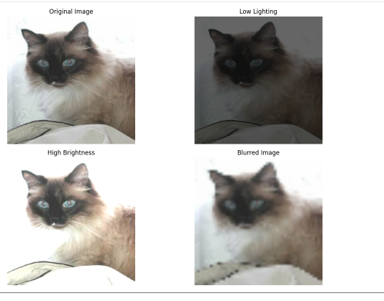
Figure 18.1: Impact of Image Quality on Prediction Performance
Description:
This figure illustrates how variations in image quality, lighting conditions, blur, and object visibility affect the prediction confidence and classification performance of the deep learning model.

18.2 Similar-Looking Animal Challenges
Certain images may contain visual similarities that reduce model confidence during prediction.
Examples include:
• Similar fur textures
• Unusual animal poses
• Partial object visibility
• Complex backgrounds
• Images containing multiple animals
These visual ambiguities may occasionally result in incorrect classifications or lower prediction confidence.
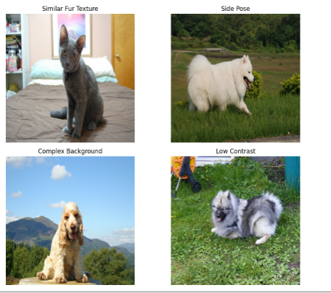
Figure 18.2: Classification Challenges for Similar Visual Patterns
Description:
This figure presents examples of visually challenging image samples where similar textures, poses, or backgrounds may reduce classification confidence between Cat and Dog categories.

18.3 Computational Resource Requirements
Training deep learning architectures such as CNN, VGG16, and ResNet50 requires significant computational resources.
Key limitations include:
• Higher GPU memory requirements
• Longer training time on CPU systems
• Increased computational complexity for transfer learning models
• Larger storage requirements for pretrained architectures
GPU acceleration significantly improves training efficiency and model experimentation speed.
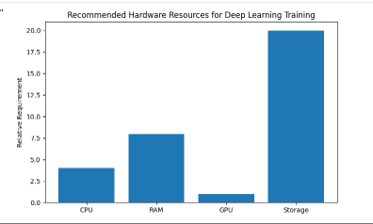
Figure 18.3: Computational Resource Requirements for Deep Learning Training
Description:
This figure illustrates the computational infrastructure requirements for training deep learning and transfer learning architectures, including GPU acceleration, memory utilization, and training efficiency considerations.

18.4 Dataset Limitations
The dataset used in this project may not fully represent all real-world image variations.
Potential dataset limitations include:
• Limited breed diversity
• Background bias
• Imbalanced lighting conditions
• Limited real-world edge cases
• Potential similarity between training and testing environments
Additional large-scale and diverse datasets could further improve model robustness and generalization capability.
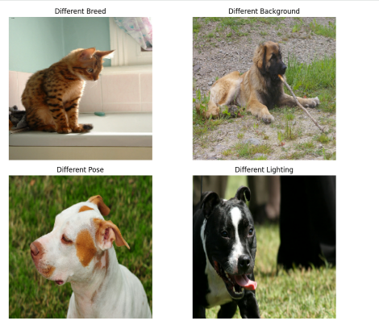
Figure 18.4: Dataset Diversity and Generalization Limitations
Description:
This figure highlights potential dataset limitations related to image diversity, breed representation, background variability, and real-world generalization challenges within the Cat vs Dog classification dataset.

18.5 Overfitting Risk in Deep Learning
Deep learning architectures are susceptible to overfitting if not properly regularized.
Potential risks include:
• Model memorization of training data
• Reduced performance on unseen images
• High training accuracy but poor generalization
To reduce these risks, the project implemented:
• Data augmentation
• Dropout regularization
• Transfer learning
• Validation monitoring
These techniques improved model stability and generalization capability.
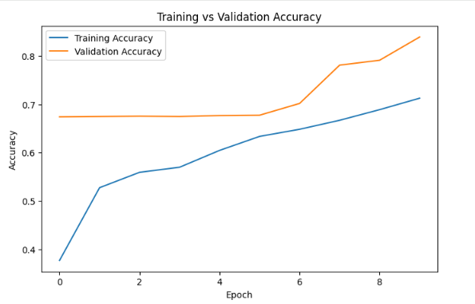
Figure 18.5: Overfitting and Generalization Analysis in Deep Learning Models
Description:
This figure illustrates the impact of regularization and augmentation techniques in reducing overfitting and improving generalization performance for Cat vs Dog image classification models.

18.6 Key Risk Observations
The project analysis revealed that:
• Image quality strongly influences prediction accuracy
• Complex backgrounds may reduce model confidence
• Transfer learning improves generalization but increases computational complexity
• GPU acceleration is highly beneficial for efficient training
• Additional diverse datasets could further improve robustness

18.7 Section Summary
• The model performance depends heavily on image quality and clarity
• Similar-looking visual patterns may occasionally reduce prediction confidence
• Deep learning architectures require significant computational resources
• Dataset diversity impacts real-world generalization capability
• Regularization and transfer learning techniques help reduce overfitting risks

19. Assumptions
The following assumptions were considered during the development, training, and evaluation of the Cat vs Dog image classification system. These assumptions help define the expected operating conditions and limitations of the deep learning pipeline.

19.1 Correct Image Labeling
The project assumes that all training and testing images are correctly labeled into their respective categories.
Class labels used:
• Cat → 0
• Dog → 1
The performance of supervised deep learning models depends heavily on accurate labeling. Incorrect labels may introduce noise and negatively affect model learning and prediction accuracy.
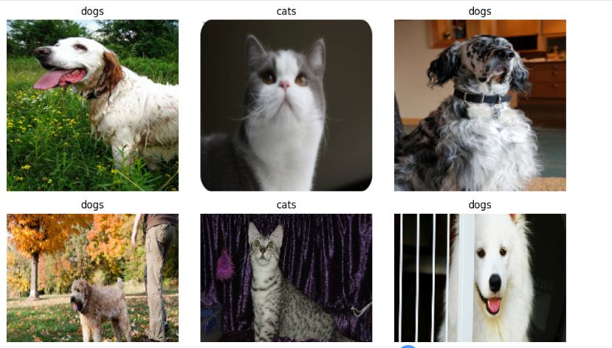
Figure 19.1: Correctly Labeled Training Image Samples
Description:
This figure illustrates properly labeled Cat and Dog image samples used during supervised deep learning training. Accurate labeling is critical for reliable feature learning and classification performance.

19.2 Input Image Quality Assumption
The model assumes that input images provided during inference are:
• Clear and visible
• Reasonably well-lit
• Free from excessive blur or distortion
• Containing identifiable animal features
Poor-quality images may reduce prediction confidence and classification reliability.
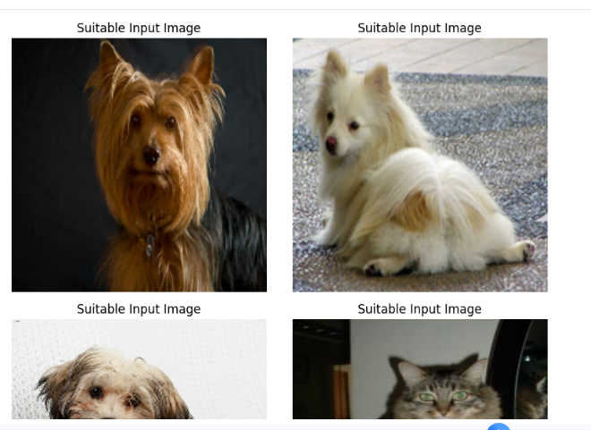
Figure 19.2: Input Image Quality Assumptions for Prediction
Description:
This figure presents examples of suitable input image conditions expected by the deep learning model, including proper lighting, object visibility, and acceptable image clarity for reliable prediction performance.

20. Retraining Strategy
Periodic retraining of the Cat vs Dog image classification model is recommended to maintain prediction accuracy, improve generalization capability, and adapt to new image variations over time.
Deep learning models may experience performance degradation when exposed to new image distributions, unseen breeds, changing image quality patterns, or real-world environmental variations not present in the original training dataset.
The retraining strategy helps ensure that the deployed AI system remains reliable, scalable, and production-ready.

20.1 Purpose of Retraining
The retraining process is designed to:
• Improve long-term model accuracy
• Handle new image variations and breeds
• Reduce performance drift over time
• Improve generalization on unseen real-world images
• Adapt to evolving deployment environments
Periodic retraining enables the deep learning system to continuously learn from updated datasets and improve prediction reliability.
Figure 20.1: Deep Learning Model Retraining Workflow
Description:
This figure illustrates the retraining workflow for the Cat vs Dog image classification system. The pipeline includes new image collection, preprocessing, model retraining, evaluation, and deployment updates to maintain long-term prediction performance.

20.2 Data Drift and Distribution Changes
Over time, deployed AI systems may encounter image distributions that differ from the original training dataset.
Potential causes include:
• New cat and dog breeds
• Different camera devices
• Changing lighting conditions
• Background complexity variations
• Low-quality mobile image uploads
• Real-world deployment edge cases
Retraining helps the model adapt to evolving image distributions and maintain stable prediction accuracy under changing real-world conditions.
Periodic monitoring and retraining ensure that the deep learning model continues to generalize effectively across unseen image variations and deployment environments.

21. Ethics & Bias Considerations
The Cat vs Dog image classification system was developed following responsible and ethical Artificial Intelligence practices. The project does not use any sensitive personal information, biometric data, or privacy-related attributes during model training or evaluation.
The dataset consists only of publicly available animal images intended for educational and research purposes. The model was designed exclusively for image classification tasks and not for any harmful, deceptive, or unauthorized applications.
Potential sources of bias may still exist due to:
• Limited breed diversity within the dataset
• Variations in lighting and background conditions
• Unequal representation of certain image styles or environments
These factors may influence model generalization performance across unseen real-world image scenarios.
To reduce bias and improve fairness, the project applied:
• Data augmentation techniques
• Diverse image preprocessing
• Transfer learning for robust feature extraction
• Validation on unseen image samples
The project promotes:
• Transparent AI development
• Responsible Computer Vision practices
• Explainable deep learning workflows
• Ethical usage of Artificial Intelligence systems
Future improvements may include larger and more diverse datasets to further reduce dataset bias and improve model fairness across broader image distributions.

22. Final Deliverables
The final project deliverables produced during the Cat vs Dog image classification project include:
• Final trained VGG16 deep learning model
• Deployment-ready model.keras file
• Deep learning implementation notebook (catdogtensorflow.ipynb)
• Model evaluation metrics and performance analysis
• Training and validation visualizations
• Project documentation and technical report
• Deployment-ready inference workflow
• Streamlit/Flask/FastAPI deployment compatibility
• Reusable Computer Vision preprocessing pipeline
These deliverables support future deployment, retraining, maintenance, and scalable AI application development.

23. Conclusion
This project successfully demonstrates an end-to-end Computer Vision workflow using Deep Learning and Transfer Learning techniques for binary image classification. Multiple architectures including ANN, CNN, VGG16, and ResNet50 were implemented, evaluated, and compared to identify the most effective model for Cat vs Dog image recognition.
The final VGG16-based transfer learning model achieved strong classification performance through advanced feature extraction, improved generalization capability, and reduced training complexity. Image preprocessing techniques such as resizing, normalization, and data augmentation further enhanced model stability and prediction reliability.
The project highlights the practical application of:
• Deep Learning
• Convolutional Neural Networks
• Transfer Learning
• Image preprocessing pipelines
• Deployment-ready AI workflows
The final solution provides:
• Accurate image classification capability
• Scalable deep learning architecture
• Real-time deployment readiness
• Reusable .keras model integration
• Production-oriented Computer Vision workflow
This project demonstrates how modern AI and transfer learning techniques can be effectively applied to solve real-world image classification problems using scalable and deployment-ready Computer Vision solutions. The final VGG16 transfer learning model achieved approximately 96% validation accuracy and demonstrated strong generalization capability for real-world AI-based image classification systems.

24. Technical Glossary

CNN (Convolutional Neural Network)
A deep learning architecture specifically designed for image processing and spatial feature extraction.

ANN (Artificial Neural Network)
A basic neural network architecture consisting of interconnected dense layers used for machine learning tasks .

Transfer Learning
A deep learning technique where pretrained model knowledge is reused for solving a new but related task.

VGG16
A pretrained deep learning architecture trained on the ImageNet dataset, widely used for image classification tasks.

ResNet50
An advanced deep learning architecture using residual learning blocks to improve deep feature extraction and training efficiency.

Epoch
One complete training cycle where the model processes the entire training dataset once.

Overfitting
A condition where the model memorizes training data and performs poorly on unseen data.

Data Augmentation
A preprocessing technique used to artificially increase dataset diversity through transformations such as rotation, flipping, and zooming.

Normalization
The process of scaling image pixel values into a smaller numerical range to improve model training stability.

Dropout
A regularization technique where certain neurons are randomly deactivated during training to reduce overfitting.

Fine-Tuning
The process of retraining selected layers of a pretrained model on a custom dataset to improve task-specific learning.

ImageNet
A large-scale image dataset commonly used for training pretrained deep learning models.

Activation Function
A mathematical function applied within neural networks to introduce non-linearity and improve learning capability.

ReLU (Rectified Linear Unit)
A commonly used activation function in deep learning that helps models learn complex patterns efficiently.

Sigmoid Function
An activation function used for binary classification tasks that produces output probabilities between 0 and 1.

GPU (Graphics Processing Unit)
A high-performance processor optimized for parallel computations and deep learning model training.

Confusion Matrix
A performance evaluation table showing correct and incorrect predictions across classification categories.

Binary Classification
A machine learning task where predictions belong to one of two classes, such as Cat or Dog.

Model Generalization
The ability of a trained model to perform accurately on unseen data.

Preprocessing Pipeline
A sequence of data preparation steps performed before model training, including resizing, normalization, and augmentation.

